Comprehensive Plan and Development Regulation Amendment Application Guide
Use this guide to submit a Comprehensive Plan Amendment or Development Regulation Amendment through the City of SeaTac's online permit portal.
Step 1: Access the Permit Portal
Go to the City of SeaTac Permitting & Licensing Portal. You will need to register for a LAMA account if you do not already have one.
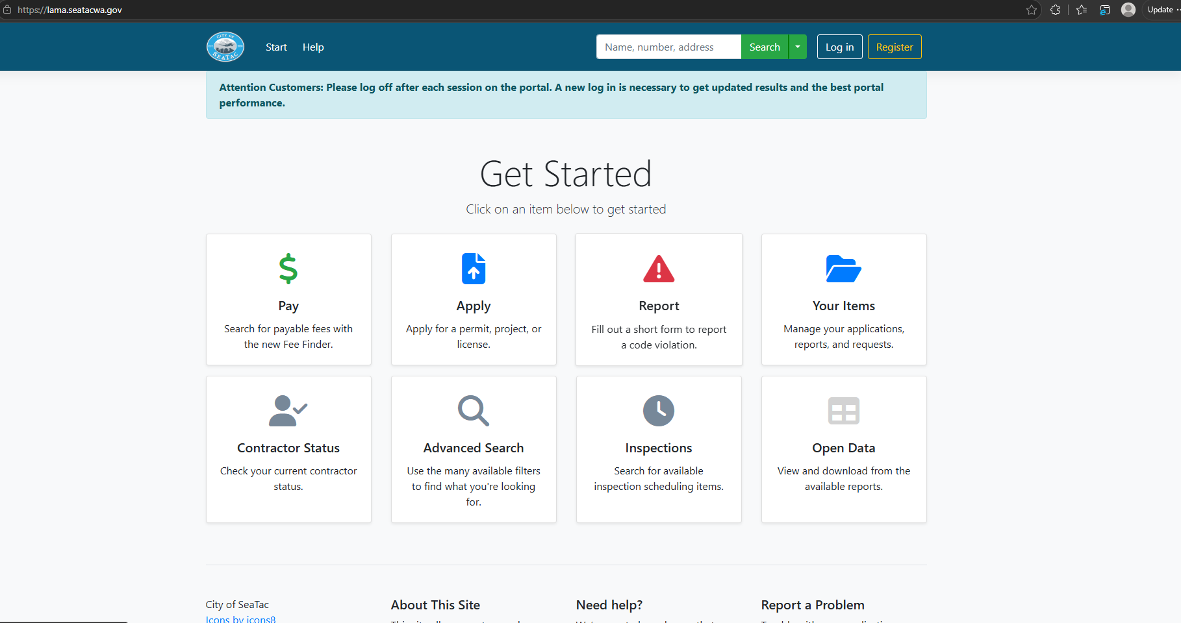
Step 2: Start a New Application
Select Apply for a Permit, Project, or License.
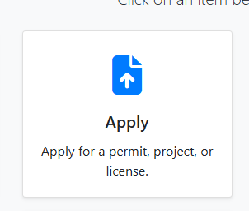
Step 3: Select the Permit Type
- Choose Planning / Land Use.
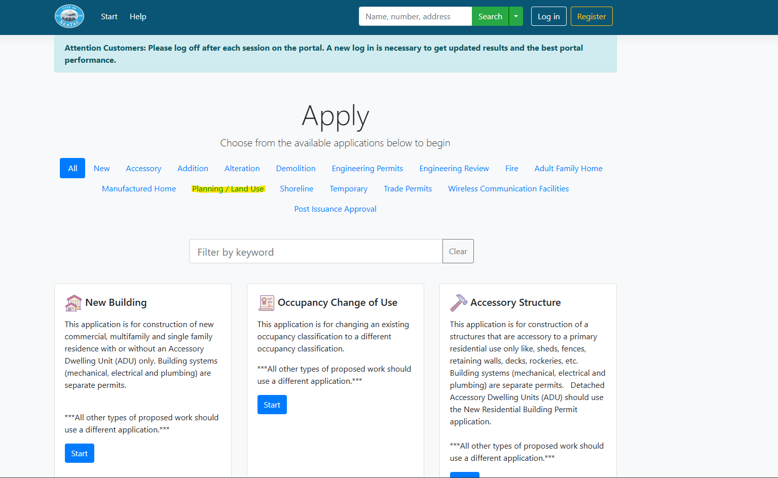
- Scroll to the bottom of the list and select Zoning Administrative Permit.
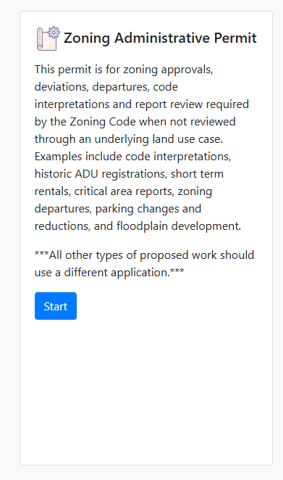
- A "Before You Begin" pop-up will appear. Amendment applications are not listed here. Select Continue.
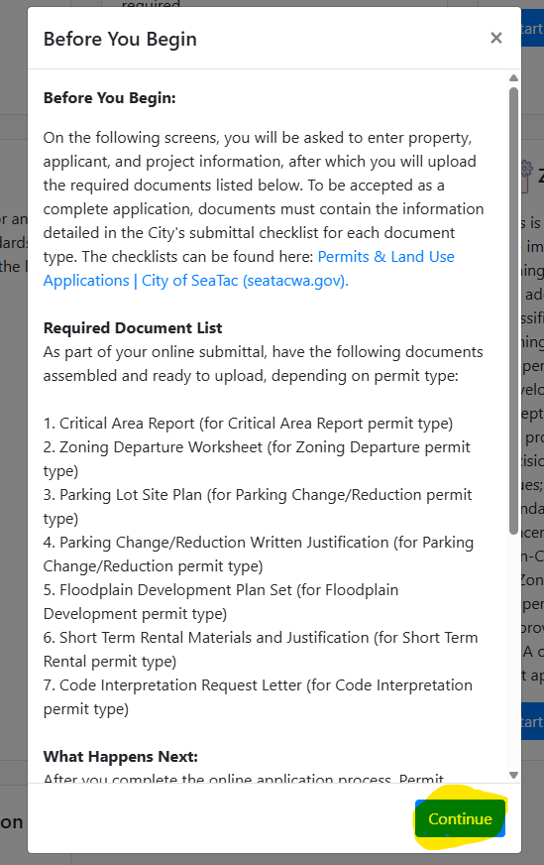
Step 4: Enter the Project Location
- Comprehensive Plan Amendment: Enter the address of the property or properties affected by the amendment.
- Development Regulation Amendment: Use City Hall as the project location:
  - Address: 4800 S 188th St, SeaTac, WA 98188
  - Parcel Number (if needed): 3423049197
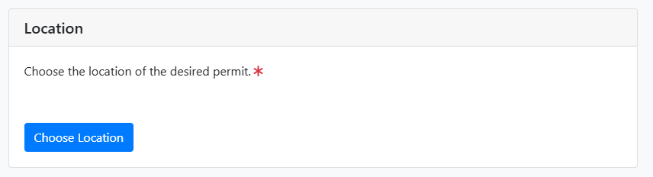
Step 5: Select the Land Use Type
When prompted to select a permit subtype, choose Other.
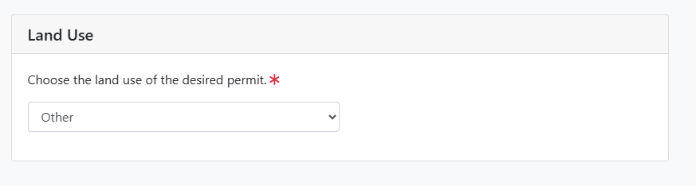
Step 6: Enter a Project Description
Provide a brief description of the request, including whether it is a:
- Comprehensive Plan Amendment
- Development Regulation Amendment
- Concurrent Rezone (if applicable)
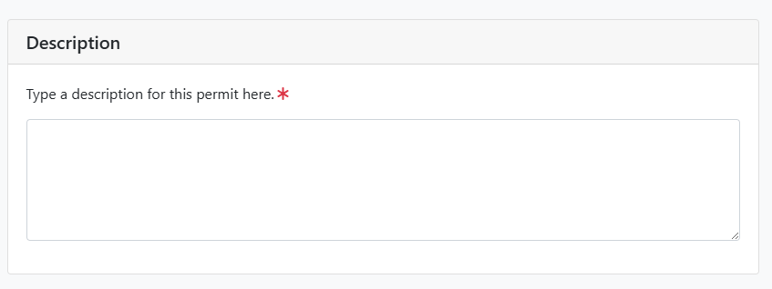
Step 7: Select the Permit Classification
Under D. Type Specific – D51 Zoning Administrative Permit, select Docket Request.
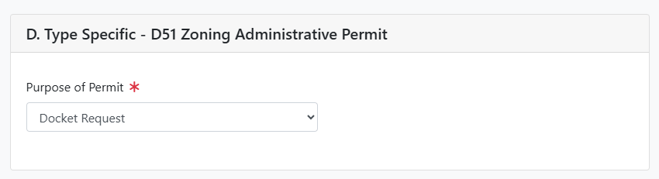
Step 8: Save and Continue
Select Save and Continue.
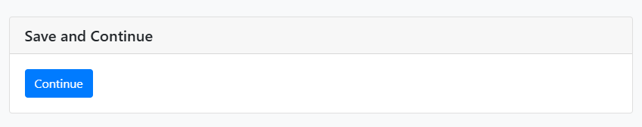
Step 9: Complete the questionnaire
These fields are unlikely and can be left blank
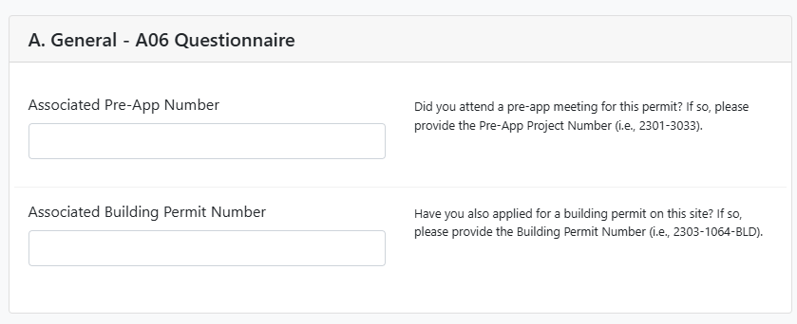
Step 10: Complete Project Contact Information
You can add multiple project contacts, but please include the main project contact and/or property owner if different.
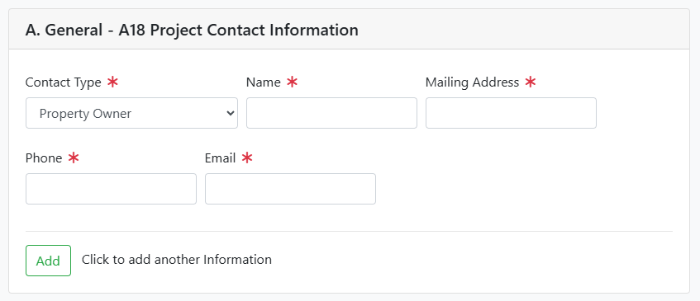
Step 11: Upload Required Documents
Upload the following materials:
- Completed amendment application (upload as Project Narrative)
- Supporting materials (upload as General Documents)
- Completed SEPA Environmental Checklist (upload as General Documents)
Additional information may be requested during the review process.
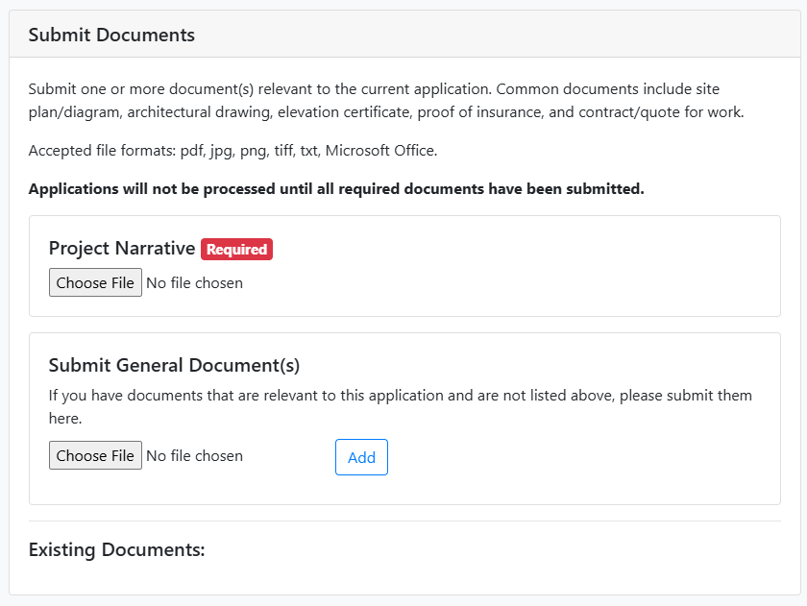

Step 12: Submit the Application
Review all information for accuracy and completeness, then submit the application.
City staff will review the application for completeness and contact you if additional information is needed.
Questions?
For questions about amendment applications, requirements, or the annual amendment process, contact the City of SeaTac Planning Division.

